By: Colin Harrison, Christian McMurtrie, Timothy Nakhisa, and Zachary Rivera

  CAKE Group

First Iteration Report

Contents

Introduction 1

Project Management Plan 1

Project Organization 1

Risk Analysis 1

Hardware and Software Resource Requirements 1

Work Breakdown 1

Project Schedule 1

Project Overview 2

Problem and Solution 2

Stakeholders 2

Scope 3

Requirements 3

Development, Operation, and Maintenance Environments 3

System Model 3

Textual Use Cases 3

User Interaction 4

Functional Requirements 4

Primary Requirements 4

Secondary Requirements 5

Nonfunctional Requirements 5

Feasibility 5

Appendices 6

Use Cases 6

System Models 9

# Introduction

Our team is Computer Applications: Knowledgeable Engineering (CAKE). The members of this team are Colin Harrison, Christian McMurtrie, Timothy Nakhisa, and Zachary Rivera. We are working with our client, Dr. Yvonne Chueh, on a website similar to MealTrain. This website is intended to help the elderly in planning and executing social events.

# Project Management Plan

## Project Organization

We will be using an agile Kanban method for solving our problem to keep organized. This will make it so we can pair program, keep in contact, and have a good developer to quality assurance ratio to constantly push out a refined product each sprint for the client. This will help our client see a consistent growth, and help us keep on track of where are project is at, where it’s going, and what changes might have to be made. Currently we are going to be using a rotation style for our team roles. Currently we will have three developers (Christian, Tim, and Zac) and one quality assurance tester (Colin). We also have designated our scrum master to be Colin, our documentation manager is Christian, and version control system manager is Zac. We will be rotating these rolls every four weeks to make sure that everyone can experience each roll.

## Risk Analysis

Possible risks are feature overload. To make this website fully functional we must implement a lot of features, but we most focus on them one at a time and not get overwhelmed. The agile Kanban organizational method will help us to not get overwhelmed, and consistent interactions with our client to be able to update, and manage expectations.

## Hardware and Software Resource Requirements

For our project, we will all need a computer, and will either need to have the most widely used browsers installed on our computers such as Firefox, Chrome, Edge, and Safari to be able to test our website on. There are also third party programs we can use that would let us tap into a multitude of different browser and operating system configurations called “Saucelabs.” Our target installation will be at least the main browsers Firefox and Chrome, then hopefully expanding to others as the project goes on.

## Work Breakdown

We will be using an iteration “onion layering” breakdown where we will start by trying to get a homepage set up. After we will fill the home page, and get tab placeholders for the next pages. We will take each feature on one at a time to get the project done.

## Project Schedule

Our goal is to reach each milestone every sprint (which is every two weeks), and updating each other during our scrum meetings a few times a week. We will hopefully be continuing to build upon each previous sprint so our dependencies would be if we completed our goals on our previous sprint. We would have a retro after a sprint and document what got done to help project our next sprint and if we are on track. With kanban we could tackle our project two ways, having separate developers working on a task at a time, or we could pair program a feature to continue the “conveyor belt” while having quality assurance continuously checking the developers last feature.

# Project Overview

This project will aim to help elderly persons facing social isolation due to the lack of nearby family members. A website will be created promoting social activities as well as more personal outings for seniors. It will allow for members of the local senior community and their distant families to stay connected.

## Problem and Solution

Rapidly advancing technology has allowed people to remain connected even when half a world apart. A person in Seattle can speak with and see a person in London in real time. Or fly from New York to Los Angeles in just a few hours. These advances have allowed people to move freely around the world and still remain in touch with family and friends from their hometowns.

These changes have also led to a group of increasingly isolated individuals; the elderly. As more families choose to relocate for work or personal reasons, the parents and grandparents often stay put in their hometowns. As they age and mobility diminishes, socializing becomes more difficult if not nearly impossible. A lack of socializing can lead to reclusion which can contribute to deteriorating health, both mentally and physically (John T Cacioppo, 2003).

The solution is to promote social outings for the aging population, whether by organizing group outings or having younger community members step in when family is not available. The vision of Dr. Chueh is to have an online site where such activities can be arranged. This would include having a system where families away from older relatives can contribute to an account funding events or meal outings that allow the older family member to socialize outside of their own home.

While software promoting social activities is not unique, it often misses on the most vunerable demographic. This software would solely focus on those who may not be familiar with or able to use computers or the internet well and who may have trouble getting out on their own.

## Stakeholders

The client is Dr. Chueh. She is a Professor of Mathematics at Central Washington University in Ellensburg, WA. She was inspired to do something for the aging community during a trip to the east coast. During this trip, she attended a funeral where the family of the departed received food and condolences from members of an online site called “Meal Train”. She recognized the good that can come from a community banding together in times of need and thought of her own family. She saw the limitations of the Meal Train site and wanted to create something that was proactive.

The elderly in communities across the globe are also stakeholders. For this project, we will limit this to the elderly in Ellensburg. They currently cope with the problem of isolation by attending (when possible) small gatherings at church’s or sometimes hosted by local retirement homes. There is no prevailing solution.

The families of the elderly who do not live near-by and are unable to visit regularly is another group of stakeholders. These people care for their family members but are rooted in homes across the country making their ability to help impractical with current resources. This site would give them a tool that will allow them to help their relatives maintain a healthy social life.

## Scope

The software will help alleviate the problem by providing a dedicated site to increasing social health among the elderly. It will provide an easy to use, senior friendly interface that will help elderly persons connect to other members of the community.

It will also create a place where distant family members can help their loved ones stay healthy and connected to society. This should reduce some of the stress that can be caused worrying about an older family member.

The site will provide a much needed tool to promote healthy social living, but the weight of utilizing the tool will still rely on people. Family members will need to donate to elderly without sufficient income to pay for their own outings. Younger members of the community will need to volunteer their time, and family members will need to use good judgement when accepting a request to take out their loved ones.

# Requirements

## Development, Operation, and Maintenance Environments

The hardware and software that will be necessary to build and maintain the project would be a computer that is “decent” enough. A computer that has an Intel core i3+ plus processor or an equivalent processor from a different manufacturer with at least 6GB RAM with a hard drive/solid state drive of at least 400GB is recommended. In terms of software, one would need at a minimum a Notepad++ for basic HTML, JavaScript, and CSS coding. Another software that one could use is Sublime Text2. Having a web browser is a must, preferably Firefox and Google Chrome. Both browsers are good for debugging and are used by most individuals.

## System Model

### Textual Use Cases

Create Profile

* 1. Username not available, try new username
  2. Password does not meet requirements, choose different password

Create Connections

2.1 Send out connection invites

2.2 Accept invited connections

2.3 Reject invited connections

Create Event

1. Select Create Event button
2. Select Event Type
   1. Select type potluck
   2. Select type outdoor activity
   3. Select type indoor activity
   4. Select type restaurant
3. Create Name
4. Create Date(s)
5. Invite
   1. Invite connections
   2. Make public

Login

1. Open site
2. Enter Password
   1. Incorrect password
      1. Reenter password
      2. Account Locked after 3 attempts
   2. Incorrect username
      1. Reenter username
3. Login

Donate

1. Login
2. Select recipient
   1. Select from connections
   2. Select donate to site
3. Donate funds
4. Recipient receives funds

(See appendices for diagrams)

## User Interaction

The program for the user is straight forward. The user will be able to interact with the website by seeing other people in their area that want to participate in the meal plan. Whether they be the host or looking for a family or a group to have a meal with. This information will be on the main page of the site for fast accessibility. The user will also be able to upload pictures or videos that they desire, that is related to organizing meals or giving other users an idea of what outdoor activities they are in to or content that has to do with their PIE experiences.

Nude images or sexual relationships will not be tolerated neither do we condone such actions, this is not a dating or chatting site. The user will also have the ability to fill out a form for when they want to volunteer and host a meal or vice versa.

## Functional Requirements

Below are the requirements of the system:

### Primary Requirements

* We need to host the website on a server
* We need a database to store information for the forms
* We will have a calendar that will be used for clients to book days where they will be organizing meals or other outdoor activities.
* We plan on having a third party service that we can implement to check the background of users/volunteers who get added on the site. This will be for security purposes.
* The website will be free for the time being until further development.

### Secondary Requirements

* Determining how users will pay for the services the website offer. WePay, amazon pay, etc.
* Translating to different languages. For restaurants that are in different language.
* Get people to join the website.
* Testing yourself by booking you and your friends for software development

## Nonfunctional Requirements

A user will be able to use our website for their needs anywhere in the world since it is in the internet. Our project is based to be used in the United States as far as the physical environment is concerned. Specifically, we will focus in Ellensburg for testing purposes but the functionality will not differ by city or state, except for the restaurants in that particular town and we can adapt to that by embedding a location service/GPS API. Currently our project does not have any other systems that it will interface on the actual website itself. We will have external links that will refer a user to either a restaurant or a third party website/program for background checking.

Conceptually, how efficient it will be in countries that are not as advanced as the United States is something that we cannot fully determine currently. Some of the factors that might hinder for our project to be something of value to others across is the world would be things such as: background checks for new users, paying system, and restaurants. But, if someone out of the country would like to assist their friend/family member in the United States, they would be able to do that with minimum limitations.

For nonfunctional requirements here is how the system will adapt to some of those instances:

**Efficiency**- The system itself will be quite efficient in terms of providing the service that the user expects the program to provide as our website is catered to a few specific things that ensure the vision statement is met without too much jargon. The user interface is designed with the concept of simplicity and no learning curve. The text and diagrams are large enough so elderly people will have little to no problem to navigate through the site.

**Reliability**- This will not be an issue for the user since our implementation is streamlined concisely with what is necessary. The only factor that may affect the system’s reliability is whether users actually sign up and interact with other users and arrange meals and outdoor activities, because if this is not accomplished, the site serves no purpose for the user.

**Portability**- This won’t be a major issue since majority of users have access to internet. Whether that be via a cellphone or a computer. For those who may not have either, libraries, school labs, and cyber cafes are other considerable option. The only downside with a user accessing it on a cellphone is that all of the content may not fit on the screen or be displayed as it would have been on a computer. Further down the road, this will be something to consider, mobile version for our website.

**Problem Size**- The problem size is big enough to make the project fun and challenging. For instance, we have to figure out how we will approach background checks without making the user feeling uncomfortable. We have to find a way of translating language in a reliable-efficient manner. We are certain that as we implement some of our core requirements, the problem size will be affected, hopefully not too drastically.

## Feasibility

In terms of feasibility, we are certain that we can finish our project by the end of winter quarter with no problem, but we are aware that some minor set backs are inevitable for various reasons, but nothing that we cannot handle.

## Appendices

### Use Cases

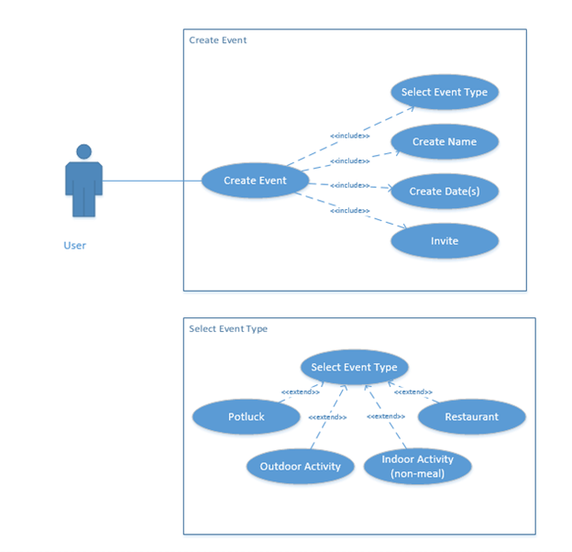

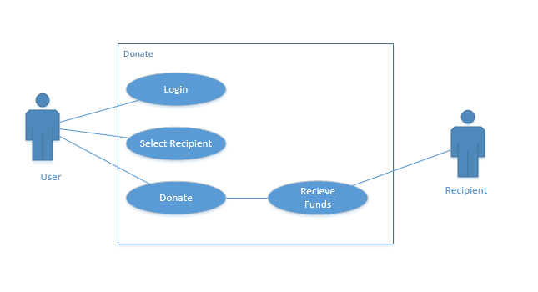

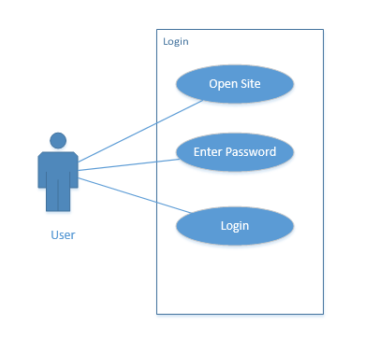

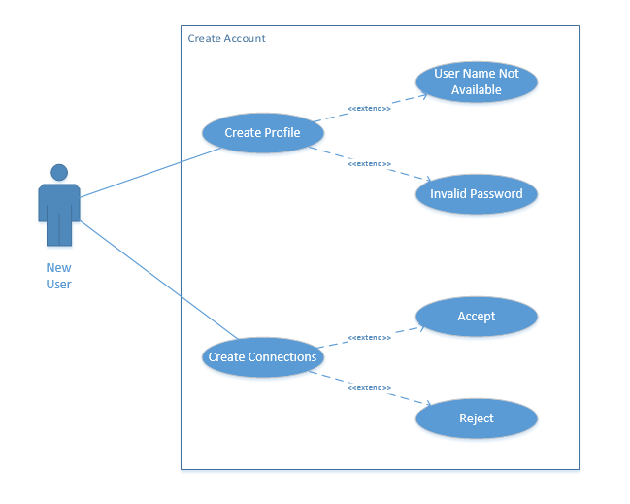

### System Models

Create Connections

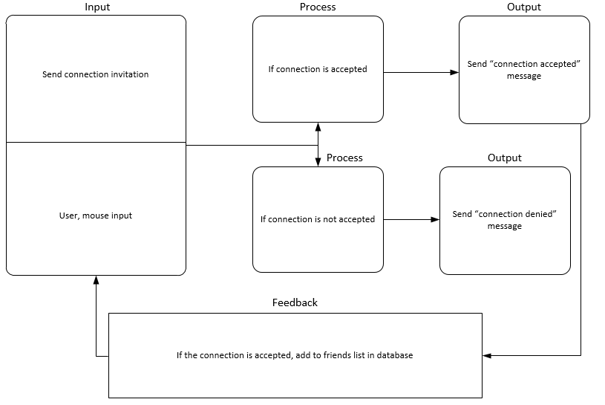

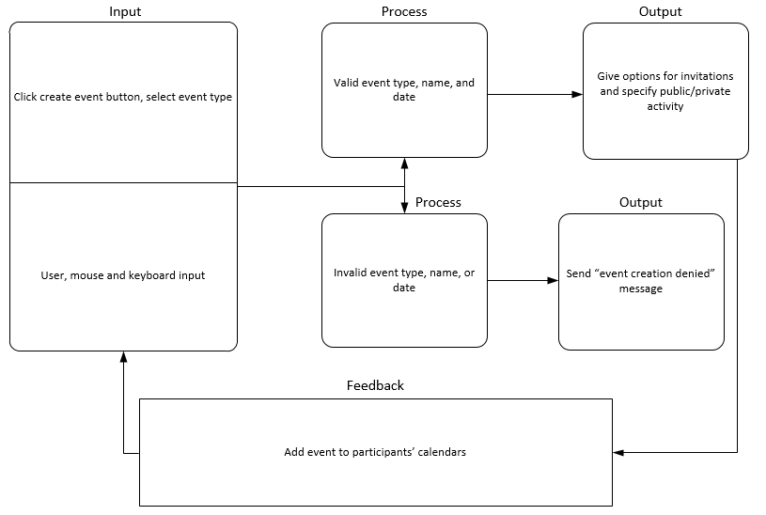

Create Event

Create Profile

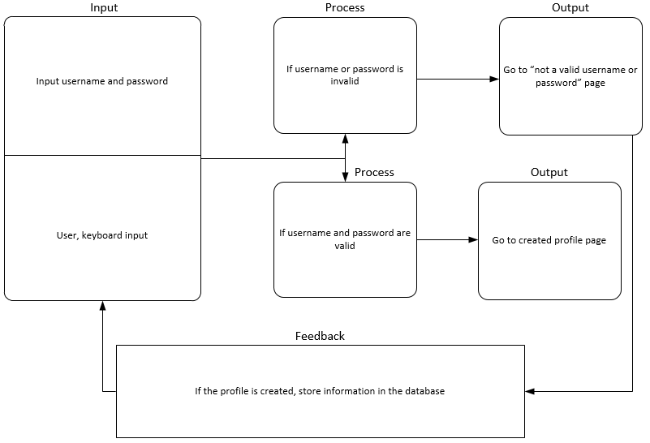

Donate

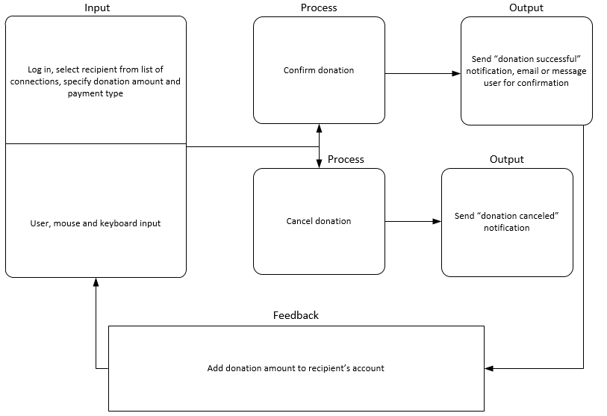

Login

